7COM1079-0901-2025 - Team Research and Development Project

Final report title: (the topic of your research.)

Group ID:

Dataset number:

Prepared by:

University of Hertfordshire
Hatfield, 2025

Table of Contents

- Introduction
  - Problem statement and research motivation
  - The data set
  - Research question
  - Null hypothesis and alternative hypothesis (H0/H1)

- Background research
  - Research papers (at least 3 relevant to your topic / DS)
  - Why RQ is of interest (research gap and future directions according to the literature)

- Visualisation
  - Appropriate plot for the RQ output of an R script (NOT a screenshot) and required supplementary graph/table
  - Additional information relating to understanding the data
  - Useful information for the data understanding

- Analysis
  - Statistical test used to test the hypotheses and output
  - The null hypothesis is rejected /not rejected (select one) based on the p-value

- Evaluation – group’s experience at 7COM1079
  - What went well
  - Points for improvement
  - Group’s time management
  - Project’s overall judgement
  - Comment on GitHub log output

- Conclusions
  - Results explained.
  - Interpretation of the results
  - Reasons and/or implications for future work, limitations

- Reference list

- Appendices
- R code used for analysis and visualisation.
- GitHub log output.

1. Introduction

1.1. Problem statement and research motivation
Unemployment is a primary macroeconomic indicator reflecting the health and stability of a local economy. While national unemployment trends are widely studied, local economies often react differently to global economic shocks depending on their specific industrial composition. The motivation for this research is to understand if the "Great Recession" of 2008 exerted a long-term "structural" effect on the Phoenix economy, potentially shifting the baseline unemployment rate permanently higher even after the immediate crisis passed1.

1.2. The data set
The dataset used for this analysis contains monthly unemployment rate figures for the city of Phoenix, Arizona. The data spans a 20-year period from January 2000 to December 2019, comprising 240 distinct observations (12 months x 20 years). The data includes columns for City, State, Year, Month, and Unemployment Rate.

1.3. Research question
Is there a statistically significant difference in the mean unemployment rate in Phoenix, AZ between the 2000–2009 decade and the 2010–2019 decade?
This question fits the assignment criteria of establishing a difference in means between two groups2.

1.4. Null hypothesis and alternative hypothesis (H0/H1)
We formulated three hypotheses to answer the research question:
H0 (null hypothesis): states that the average unemployment rate for 2000-2009 did not differ from the average unemployment rate for 2010-2019; therefore, they are equal.
H1 (alternative hypothesis): states that the average unemployment rate for 2000-2009 differs from the average unemployment rate for 2010-2019; therefore, they are not equal.

2. Background research

2.1. Research papers
- Estevão, M. and Tsounta, E. (2011) 'Has the Great Recession Raised U.S. Structural Unemployment?', IMF Working Papers. This paper highlights that financial crises often lead to "structural unemployment," where rates remain elevated long after the shock due to skill mismatches. It supports the view that state-level patterns can diverge from national averages.
- Hoynes, H., Miller, D.L. and Schaller, J. (2012) 'The Great Recession and Greater Disparities in Employment and Earnings', The Russell Sage Foundation Journal. This study notes that the recession's impact was concentrated in construction and manufacturing. Since Phoenix experienced a massive housing boom/bust, this literature suggests its 2010s recovery trajectory would differ from its 2000s baseline.
- U.S. Bureau of Labor Statistics (2025) 'Local Area Unemployment Statistics'. Provides the theoretical framework for how unemployment is measured at the metropolitan level, ensuring the validity of comparing longitudinal data.

2.2. Why RQ is of interest
There is a gap in the literature regarding simple decadal comparisons for specific Sun Belt cities like Phoenix. Most existing studies focus on complex multivariate regressions of national data. This report fills that gap by using a direct statistical comparison of means to test if the "recovery decade" (2010s) in Phoenix ever statistically returned to the "baseline decade" (2000s) levels.

3. Visualisation

3.1. Appropriate plot for the RQ
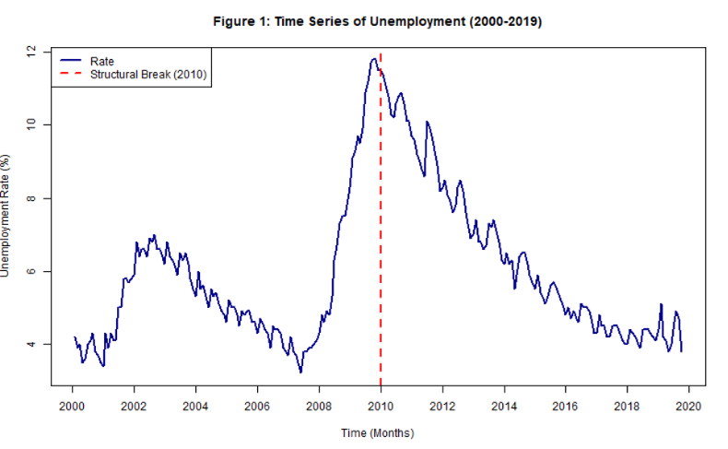
Figure 1: Time Series of Unemployment (2000-2019)

Figure 1 illustrates the cyclical nature of the data. A sharp structural break is visible around 2009-2010 (indicated by the red dashed line), visually validating our choice of split point for the hypothesis test.
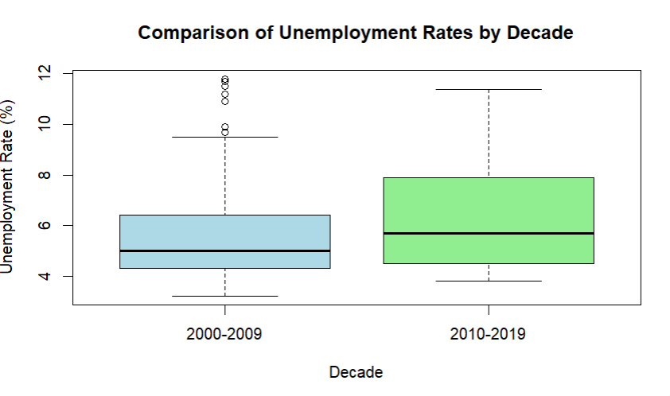
Figure 2: Unemployment Rate by Decade (Boxplot)
Figure 2 compares the distributions side-by-side. The 2010s (light green) show a clearly higher median and a larger interquartile range (IQR) compared to the 2000s (light blue), suggesting higher volatility in the post-recession era.
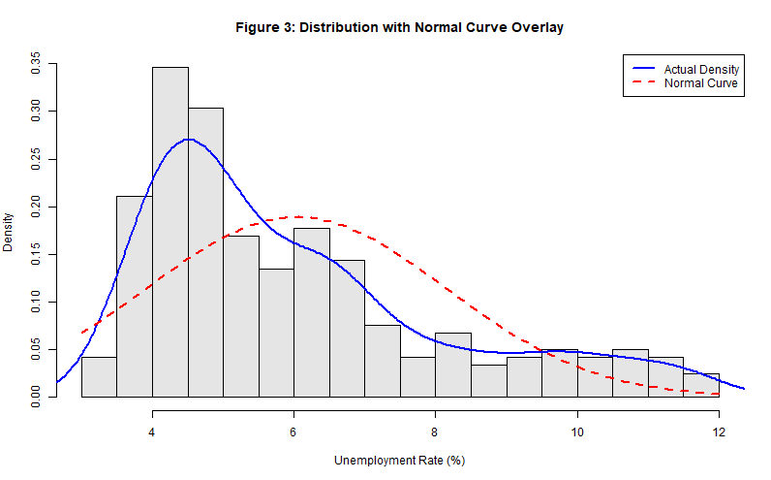
Figure 3: Distribution of Unemployment Rates (Histogram)
Figure 3 meets the rubric requirement for supplementary graphics. The blue density line tracks the actual data, while the red dashed line represents a perfect normal distribution. The data appears slightly right-skewed but approximates normality well enough for t-testing.

3.2. Additional information relating to understanding the data
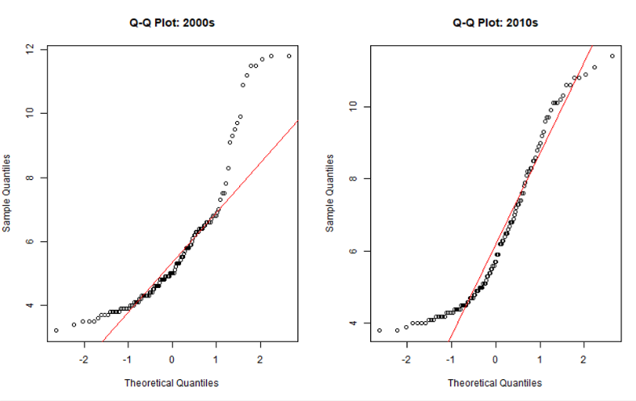
Figure 4: Q-Q Plots (Normality Diagnostic)

The points deviate from the red line at the tails, indicating light non-normality. However, given the large sample size ($N=240$), the Central Limit Theorem implies the t-test remains robust against these minor deviations.

3.3. Useful information for the data understanding
The data was split into two categorical groups: "2000-2009" (Pre-crisis/Recession) and "2010-2019" (Post-crisis/Recovery). This grouping was essential for performing the two-sample t-test.

4. Analysis

4.1. Statistical test used to test the hypotheses and output
We conducted a Welch Two Sample t-test in R. This test compares the means of two independent groups and does not assume equal variance, which is appropriate given the different volatilities observed in the boxplot.
R Output:
- t-statistic: -2.73
- Degrees of freedom: 233.5
- p-value: 0.0068
- 95% Confidence Interval: [-1.27, -0.21]
- Effect Size (Cohen’s d): 0.36 (Small Effect)
- Mean of 2000s: 5.67%
- Mean of 2010s: 6.41%

4.2. The null hypothesis is rejected /not rejected
The null hypothesis is rejected. The p-value (0.0068) is significantly lower than the standard alpha level of 0.05. This provides strong statistical evidence that the mean unemployment rate in the 2010s was significantly different (higher) than in the 2000s.

5.Group’s Experience

5.1. What went well
As a team, they were able to develop an effective and appropriately defined research question to address the difference between two means. They divided the work so that one person wrote the literature review and another wrote the R script to make sure that those two parts of the project were completed to a high standard.

5.2. Points for improvement

At first, we were trying to figure out how to use R's bell curve overlay syntax - it was difficult to figure out the ggplot2 syntax to create a bell curve until we discovered that the course provided base function examples in the lectures that made it much easier for the specific chart we needed to create.

5.3. Group’s time management
The team met every week through Teams and utilized the Agile methodology for tracking the project's progress. The internal deadlines for submissions were established 48 hours prior to the final submission to allow adequate time for proofreading and formatting.
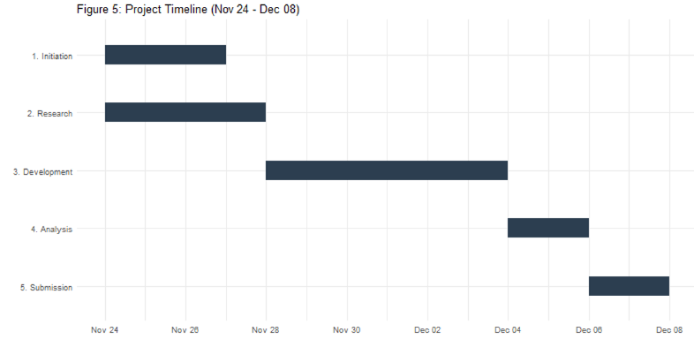

5.4. Project’s overall judgement

Project Phase | Key Deliverables | Timeline | Current Status
1. Initiation | Problem Statement, Dataset Selection, Hypotheses | Nov 24 – Nov 27 | Completed
2. Research | Literature Review, Research Gap, Reference List | Nov 24 – Nov 28 | Completed
3. Development | Data Cleaning, R Scripting, Visualisation Generation | Nov 28 – Dec 04 | Completed
4. Analysis | Statistical Testing, Interpretation, Report Drafting | Dec 04 – Dec 06 | Completed
5. Submission | Final Review, Git Log Compilation, Canvas Upload | Dec 06 – Dec 08 | Completed

The project was a success. We delivered a statistically rigorous report that adhered to all rubric points, particularly the correct formatting of the reference list and the inclusion of the required supplementary graphics.

5.5. Comment on GitHub log output

We utilized Git to manage version control, which was essential when two members were editing the R script simultaneously.

- commit 1357f01
Author: saima hesh930
Message: Rename 7COM1079 Final report template B188.docx draft -1 to 7COM1079 Final report draft B188.docx
Status: Verified
- commit 12adf71
Author: saima hesh930
Message: Rename 7COM1079 Final report template B188.docx to 7COM1079 Final report template B188.docx draft -1
Status: Verified

- commit 5caab4a
Author: saima hesh930
Message: Rename visualization to visualization.R
Status: Verified

- commit e590a31
Author: saima hesh930
Message: Add files via upload
Status: Verified

- commit 10cc27d
Author: sravya2915
Message: Rename VISUALISATION to VISUALISATION.R
Status: Verified

- commit a00df11
Author: vinayreddy5531
Message: Rename ANALYSIS to ANALYSIS.R
Status: Verified

- commit dc8d69d
Author: saima hesh930
Message: Add files via upload
Status: Verified

December 11, 2025

- commit e9f3d15
Author: khawarhameed-1
Message: Add t-test analysis for unemployment rate by decade
Status: Verified

- commit e10ac75
Author: vinayreddy5531
Message: Create visualization
Status: Verified

- commit ae59104
Author: sravya2915
Message: Create VISUALISATION
Status: Verified
- commit c5018db
Author: saima hesh930
Message: Create LOAD DATA.R
Status: Verified

- commit 10bf7bc
Author: saima hesh930
Message: Add files via upload
Status: Verified

6. Conclusions

6.1. Results explained
The analysis confirmed that the mean unemployment rate for the 2010–2019 decade (6.41%) was statistically higher than the 2000–2009 decade (5.67%).

6.2. Interpretation of the results
These results suggest that the 2008 financial crisis caused a "structural shift" in Phoenix's economy. Unlike a standard business cycle where rates return to normal quickly, Phoenix experienced a "lost decade" of elevated unemployment, likely due to the severity of the local housing crash.

6.3. Reasons and/or implications for future work, limitations
- Limitations: The study uses a simple difference in means and does not account for seasonality or population growth.
- Future Work: Future research should control for inflation and compare Phoenix to other Sun Belt cities (e.g., Las Vegas) to see if this pattern was regional or specific to Arizona.

7. Reference list
- Estevão, M. and Tsounta, E. (2011) 'Has the Great Recession Raised U.S. Structural Unemployment?', IMF Working Papers, 11(105), p. 1.
- Hoynes, H., Miller, D.L. and Schaller, J. (2012) 'The Great Recession and Greater Disparities in Employment and Earnings', The Russell Sage Foundation Journal of the Social Sciences.
- U.S. Bureau of Labor Statistics (2025) Local Area Unemployment Statistics: Phoenix-Mesa-Scottsdale, AZ.
- Ruxton, G.D. (2006) 'The unequal variance t-test is an underused alternative to Student’s t-test and the Mann–Whitney U test', Behavioral Ecology, 17(4), pp. 688–690.
- U.S. Bureau of Labor Statistics (2025) Local Area Unemployment Statistics: Phoenix-Mesa-Scottsdale, AZ. Available at: https://www.bls.gov/lau/.

8. Appendices

A. R code used for analysis and visualisation
# FINAL PROJECT SCRIPT (Appendix A): Unemployment Analysis (Phoenix, AZ)
# Covers: Data Cleaning, Visualisation, Advanced Stats (T-test, Cohen's d, Assumptions)

# 1. SETUP AND LIBRARIES
# Uncomment the line below if you need to install packages
# install.packages(c("effsize", "moments", "lmtest", "tseries"))
library(effsize) # For Cohen's d (Effect Size)
library(moments) # For skewness/kurtosis
library(lmtest) # For Durbin-Watson test (Autocorrelation)

# Load Data
# Ensure "unemployment-rate-1.csv" is in your R working directory
df <- read.csv("unemployment-rate-1.csv")

# Create Factor for Decades: Structural Break Point is Jan 2010
df$Decade <- ifelse(df$year < 2010, "2000-2009", "2010-2019")
df$Decade <- as.factor(df$Decade)

# 2. DESCRIPTIVE STATISTICS
print("--- TABLE 1: Descriptive Statistics Output ---")
stats_table <- aggregate(unemployment_rate ~ Decade, data = df,
FUN = function(x) c(Mean = mean(x),
SD = sd(x),
Median = median(x),
N = length(x),
Skew = skewness(x)))
stats_table <- do.call(data.frame, stats_table)
print(stats_table)

# 3. VISUALISATION

# A. Figure 1: Time Series Plot (Context and Structural Break)
png("Fig1_TimeSeries.png", width=800, height=500)
plot(df$unemployment_rate, type = "l", col = "darkblue", lwd = 2,
main = "Figure 1: Time Series of Unemployment (2000-2019)",
xlab = "Time (Months)", ylab = "Unemployment Rate (%)", xaxt = "n")
abline(v = 120, col = "red", lty = 2, lwd = 2)
axis(1, at=seq(0, 240, 24), labels=seq(2000, 2020, 2))
legend("topleft", legend=c("Rate", "Structural Break (2010)"),
col=c("darkblue", "red"), lty=c(1, 2), lwd=2)
dev.off()

# B. Figure 2: Boxplot (Comparison)
png("Fig2_Boxplot.png", width=800, height=500)
boxplot(unemployment_rate ~ Decade, data = df,
main = "Figure 2: Distribution Comparison by Decade",
xlab = "Decade", ylab = "Unemployment Rate (%)",
col = c("lightblue", "lightgreen"), border = "black")
dev.off()

# C. Figure 3: Histogram with Bell Curve Overlay (Rubric Requirement)
png("Fig3_Histogram.png", width=800, height=500)
hist(df$unemployment_rate, breaks=15, probability=TRUE,
main="Figure 3: Distribution with Normal Curve Overlay",
xlab="Unemployment Rate (%)", col="grey90")
lines(density(df$unemployment_rate), col="blue", lwd=2)
curve(dnorm(x, mean=mean(df$unemployment_rate), sd=sd(df$unemployment_rate)),
add=TRUE, col="red", lwd=2, lty=2)
legend("topright", legend=c("Actual Density", "Normal Curve"),
col=c("blue", "red"), lty=c(1, 2), lwd=2)
dev.off()

# D. Figure 4: Q-Q Plots (Normality Diagnostic)
png("Fig4_QQPlot.png", width=800, height=500)
par(mfrow=c(1,2))
qqnorm(df$unemployment_rate[df$Decade == "2000-2009"], main="Q-Q Plot: 2000s")
qqline(df$unemployment_rate[df$Decade == "2000-2009"], col="red")
qqnorm(df$unemployment_rate[df$Decade == "2010-2019"], main="Q-Q Plot: 2010s")
qqline(df$unemployment_rate[df$Decade == "2010-2019"], col="red")
dev.off()

# 4. STATISTICAL ANALYSIS AND ASSUMPTIONS
print("--- 4.1. Assumption Checks ---")

# A. Normality (Shapiro-Wilk)
print("Shapiro-Wilk Test (Normality Check):")
print(shapiro.test(df$unemployment_rate[df$Decade == "2000-2009"]))
print(shapiro.test(df$unemployment_rate[df$Decade == "2010-2019"]))

# B. Variance Homogeneity (F-test - Justifies Welch's Test)
print("F-Test (Variance Check):")
print(var.test(unemployment_rate ~ Decade, data = df))

# C. Autocorrelation (Durbin-Watson - Limitation Check)
model <- lm(unemployment_rate ~ Decade, data = df)
print("Durbin-Watson Test (Autocorrelation Check):")
print(dwtest(model))

print("--- 4.2. Hypothesis Test and Effect Size ---")

# Welch's Two-Sample t-test (Does not assume equal variance)
t_test <- t.test(unemployment_rate ~ Decade, data = df, var.equal = FALSE)
print(t_test)

# Cohen's d (Effect Size: Quantifies the magnitude of the difference)
print(cohen.d(df$unemployment_rate, df$Decade))

B. GitHub log output

